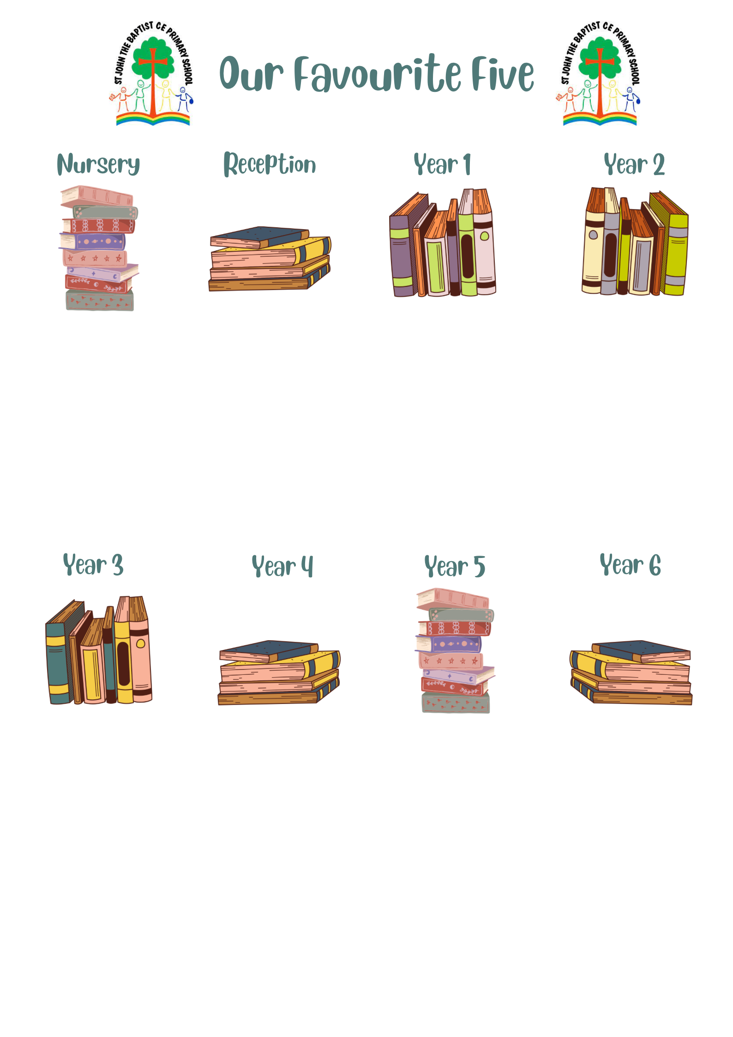

The Enchanted Wood - Enid Blyton

Dogger - Shirley Hughes

Tree - Britta Teckentrup

The Tiger Who Came to Tea - Judith Kerr

Looking after our Planet- Katie Daynes

The Singing Mermaid - Julia Donaldson

Oi Frog! - Kes Gray

The Blue Penguin - [Petr Horáček](https://www.google.com/search?safe=active&sca_esv=566224941&rlz=1C1GCEA_enGB924GB925&q=Petr+Hor%C3%A1%C4%8Dek&si=ALGXSlZU63x8z7xlCa27RXiAG2NButbVxA_Eksbf-9a1ezBX8Sh7LGtwwdysi2TjgjeEtwEsLzvA3n8Y4mUDw7ZK5iWVU0fYC4F2eIwtWBM4yRRnJJdw1wagOmd9VXR461pejoBVV-c4JGRkNTdc5el25AvFhQr5dXxda7gKGuTqYQpS_uulzkzFMpFSm1YoKlTVDrmZpLP5wlAVAFHHOFaBhny236mZeQ%3D%3D&sa=X&ved=2ahUKEwiW7-Lk8rOBAxWuQ0EAHYDWDn0QmxMoAHoECCIQAg)

Five Minutes Peace - Jill Murphy

What a Waste - Jess French

We’re Going on a Bear Hunt - Michael Rosen

Owl Babies - Martin Waddell

The Gruffalo - Julia Donaldson

Peace at Last - Jill Murphy

Love Our Earth - Jane Cabrera

The Last Bear

The Highland Falcon Thief

Roman Diary, The Journal of Iliona

The Chronicles of Narnia, The Lion, the Witch and the Wardrobe

The Boy at the Back of the Class

Where the poppies grew

How to catch a star

Charlotte’s Web

Mr Tiger, Betsy and the Blue Moon

The Wild Way Home

The Creakers

The Journey

Interstellar Cinderella

Leaf

The Great Paper Caper

Dougal’s Deep-Sea Diary

I am Seed that grew the tree

Guy Fawkes and the Gunpowder plot

Our Favourite Books…

Coming to England-

Into the Volcano

Skellig

The Nowhere Emporium

The Ancient Egypt Sleepover

Flotsam

Journey to the River Sea

Can You See Me?

Clockwork

Letters from the Lighthouse

The Arrival